A Project Report on

EFFECTIVE PATTERN DISCOVERY FOR
TEXT MINING

Submitted to the Dept. of Information Technology, SNIST
in the partial fulfillment of the academic requirements for the award of
B. Tech (Information Technology)
Under JNTUH

By

V.SHESHU KUMAR (11311A1278)
K.SAI SURAJ (11311A1279)
V. VAMSHI KRISHNA (11311A12A1)
S.VIVEK ROSHAN (11311A12A8)

Under the guidance of
Ms. G. SUMALATHA
Assistant professor
Internal Guide


Department of Information Technology
School of Computer Science and Informatics
SreeNidhi Institute of Science and Technology (An Autonomous Institution)
Yamnampet, Ghatkesar Mandal, R. R. Dist., Hyderabad – 501301

Affiliated to
Jawaharlal Nehru Technological University Hyderabad
Hyderabad – 500 085
2014–15
Department of Information Technology
School of Computer Science and Informatics
Sreenidhi Institute of Science and Technology (An autonomous Institution)

CERTIFICATE

This is to certify that the Major-Project report on “Effective Pattern Discovery for Text Mining” is a bonafide work carried out by V. SHESHU KUMAR (11311A1278), K. SAI SURAJ (11311A1279), V.VAMSHI KRISHNA (11311A12A1), S.VIVEK ROSHAN (11311A12A8) in the partial fulfillment for the award of B.Tech degree in Information Technology, Sreenidhi Institute of Science and Technology, Hyderabad, affiliated to Jawaharlal Nehru Technological University Hyderabad (JNTUH), Hyderabad under our guidance and supervision.

The results embodied in the Project work have not been submitted to any other University or Institute for the award of any degree or diploma.

Internal guide Head of the Department

(Ms. G.Sumalatha) (Dr. V. V. S. S. S. Balaram)

Acknowledgement

We would like to express our immense gratitude and sincere thanks to G.Sumalatha, Assistant Professor of Information Technology for her guidance, valuable suggestions and encouragement in completing the Major-Project work within the stipulated time.

We would like to express our sincere thanks to Dr. P. Narasimha Reddy, Executive Director, K. Sumanth, Principal, Dr. V. Umakanta Sastry, Director, School of Computer Science and Informatics, Dr. V. V. S. S. S. Balaram, Professor & Head of the Department of Information Technology, Mr. K. Kranthi Kumar, Assistant Professor & Project Coordinator of the Department of Information Technology, Sreenidhi Institute of Science and Technology (An Autonomous Institution), Hyderabad for permitting us to do our Project work.

Finally, we would also like to thank the people who have directly or indirectly helped us and parents and friends for their cooperation in completing the Major-Project work.

V.SHESHU KUMAR (11311A1278)
K.SAI SURAJ (11311A1279)
V. VAMSHI KRISHNA (11311A12A1)
S.VIVEK ROSHAN (11311A12A8)

CONTENTS
ABSTRACT

- INTRODUCTION PAGE NO.
  - Introduction to the Project 02
  - Purpose of the Project 02
  - Project Scope 02
  - Overview 03
    - Project Steps 03
  - Existing System 03
  - Proposed System 04

- LITERATURE SURVEY
  - Text Mining & Data Mining 05
  - Base Paper Survey 06

- SYSTEM ANALYSIS
  - Study of the System 10
  - Requirements Analysis 11
  - System Architecture 18
  - Data Flow Diagram 18
  - Feasibility Study 19
3.5.1 Technical Feasibility 20
3.5.2 Operational Feasibility 20
3.5.3 Economical Feasibility 21
3.6. Functional Requirements Specification 21
3.7. Performance Requirements 22
3.8. H/W System Configuration 23
3.9. S/W System Configuration 23
- INTRODUCTION TO JAVA 24

- SYSTEM DESIGN

  - . Introduction 29
  - . Input & Output Representation 29
  - . UML Diagrams 31

- OUTPUT SCREENS 39

- SYSTEM TESTING

  - Introduction To Testing 52
  - Testing Strategies 52
  - Test Case 54
7.3.1 Test Case Document 56

8. CONCLUSION 58

9. BIBILOGRAPHY 59

ABSTRACT

Many data mining techniques have been proposed for mining useful patterns in text documents. However, how to effectively use and update discovered patterns is still an open research issue, especially in the domain of text mining. Since most existing text mining methods adopted term-based approaches, they all suffer from the problems of polysemy and synonymy. Over the years, people have often held the hypothesis that pattern (or phrase)-based approaches should perform better than the term-based ones, but many experiments do not support this hypothesis. Here an innovative and effective pattern discovery technique which includes the processes of pattern deploying and pattern evolving, to improve the effectiveness of using and updating discovered patterns for finding relevant and interesting information.
Here we present an effective pattern discovery technique, which first calculates discovered specificities of patterns and then evaluates term weights according to the distribution of terms in the discovered patterns rather than the distribution in documents for solving the misinterpretation problem. It also considers the influence of patterns from the negative training examples to find ambiguous (noisy) patterns and try to reduce their influence for the low-frequency problem. The process of updating ambiguous patterns can be referred as pattern evolution. The proposed approach can improve the accuracy of evaluating term weights because discovered patterns are more specific than whole documents.
- Introduction
1.1 Introduction to the project:
There is a significant number of data mining techniques have been presented in order to perform different knowledge tasks. These techniques include association rule mining, frequent item set mining, sequential pattern mining, maximum pattern mining, and closed pattern mining. Most of them are proposed for the purpose of developing efficient mining algorithms to find particular patterns within a reasonable and acceptable time frame. In this project, we focus on the development of a knowledge discovery model to effectively use and update the discovered patterns and apply it to the field of text mining.
1.2 Purpose of the project:
Many data mining techniques have been proposed for mining useful patterns in text documents. However, how to effectively use and update discovered patterns is still an open research issue, especially in the domain of text mining. Since most existing text mining methods adopted term-based approaches, they all suffer from the problems of polysemy and synonymy. Over the years, people have often held the hypothesis that pattern (or phrase)-based approaches should perform better than the term-based ones, but many experiments do not support this hypothesis. Here an innovative and effective pattern discovery technique which includes the processes of pattern deploying and pattern evolving, to improve the effectiveness of using and updating discovered patterns for finding relevant and interesting information. Substantial experiments on RCV1 data collection and TREC topics demonstrate that the proposed solution achieves encouraging performance.
1.3 Project Scope:
The Scope of the project is to provide maximum services to the user with the fast response and retrieval of the related output. The handled data memory size is reduced under this project. And it also facilitates with the relevant and accurate results .The main aspect is that we decrease the number of iterations required to compare keywords of a text file when searching by optimizing algorithm.

1.4 Overview:
Many types of text representations have been proposed in the past. This project presents an effective pattern discovery technique, which first calculates discovered specificities of patterns and then evaluates term weights according to the distribution of terms in the discovered patterns rather than the distribution in documents for solving the misinterpretation problem.
1.4.1. Project Steps:
Start
1. Uploading a File from a database of different files.
2. Assign the terms to the paragraph set ( dp1,dp2 )
3. Divide the terms using a Delimiter ( “ , “ )
4. Provide a minimum support.
5. Process the Algorithm with the assigned terms.
6. Process the terms with the Algorithm (Pattern Taxonomy Model).
7. Generate the Frequent Item Set with their Support counts.
8. We optimize the terms within the processed Frequent Items.
9. Find out the partial and the complete trees.
10. Compare both partial and the complete trees.
11. Exit
1.5 Existing System:
Since most existing text mining methods adopted term-based approaches, they all suffer from the problems of polysemy and synonymy. Over the years, people have often held the hypothesis that pattern (or phrase)-based approaches should perform better than the term-based ones, but many experiments do not support this hypothesis.

Disadvantages:
1. Phrases have inferior statistical properties to terms,
2. They have low frequency of occurrence, and
3. There are large numbers of redundant and noisy phrases among them
1.6 Proposed System:
Here we present an effective pattern discovery technique, which first calculates discovered specificities of patterns and then evaluates term weights according to the distribution of terms in the discovered patterns rather than the distribution in documents for solving the misinterpretation problem. It also considers the influence of patterns from the negative training examples to find ambiguous (noisy) patterns and try to reduce their influence for the low-frequency problem. The process of updating ambiguous patterns can be referred as pattern evolution. The proposed approach can improve the accuracy of evaluating term weights because discovered patterns are more specific than whole documents.
Advantages:
- The proposed approach is used to improve the accuracy of evaluating term weights.
- Because, the discovered patterns are more specific than whole documents.
- To avoiding the issues of phrase-based approach to using the pattern-based approach.
- Pattern mining techniques can be used to find various text patterns.
- Literature Survey
Text Mining is the discovery by computer of new, previously unknown information, by automatically extracting information from different written resources. A key element is the linking together of the extracted information together to form new facts or new hypotheses to be explored further by more conventional means of experimentation. Text mining is different from what are familiar with in web search. In search, the user is typically looking for something that is already known and has been written by someone else. The problem is pushing aside all the material that currently is not relevant to your needs in order to find the relevant information. In text mining, the goal is to discover unknown information, something that no one yet knows and so could not have yet written down. Text mining is a variation on a field called data mining ,that tries to find interesting patterns from large databases. Text mining, also known as Intelligent Text Analysis, Text Data Mining or Knowledge-Discovery in Text (KDT), refers generally to the process of extracting interesting and non-trivial information and knowledge from unstructured text. Text mining is a young interdisciplinary field which draws on information retrieval, data mining, machine learning, statistics and computational linguistics. As most information (over 80%) is stored as text, text mining is believed to have a high commercial potential value.
Knowledge may be discovered from many sources of information, yet, unstructured texts remain the largest readily available source of knowledge. The problem of Knowledge Discovery from Text (KDT) is to extract explicit and implicit concepts and semantic relations between concepts using Natural Language Processing (NLP) techniques. Its aim is to get insights into large quantities of text data. KDT, while deeply rooted in NLP, draws on methods from statistics, machine learning, reasoning, information extraction, knowledge management, and others for its discovery process. KDT plays an increasingly significant role in emerging applications, such as Text Understanding.

2.1 Text Mining and Data Mining
Text mining is similar to data mining, except that data mining tools are designed to handle structured data from databases , but text mining can work with unstructured or semi-structured data sets such as emails, full-text documents and HTML files etc. As a result, text mining is a much better solution for companies. To date, however, most research and development efforts have centered on data mining efforts using structured data. The problem introduced by text mining is obvious: natural language was developed for humans to communicate with one another and to record information, and computers are a long way from comprehending natural language.
Humans have the ability to distinguish and apply linguistic patterns to text and humans can easily overcome obstacles that computers cannot easily handle such as slang, spelling variations and contextual meaning. However, although our language capabilities allow us to comprehend unstructured data, we lack the computer’s ability to process text in large volumes or at high speeds. Figure 1 on next page, depicts a generic process model for a text mining application.

  - Base Paper Survey:
Due to the rapid growth of digital data made available in recent years, knowledge discovery and data mining have attracted a great deal of attention with an imminent need for turning such data into useful information and knowledge. Many applications, such as market analysis and business management, can benefit by the use of the information and knowledge extracted from a large amount of data. Knowledge discovery can be viewed as the process of nontrivial extraction of information from large databases, information that is implicitly presented in the data, previously unknown and potentially useful for users. Data mining is therefore an essential step in the process of knowledge discovery in databases. In the past decade, a significant number of data mining techniques have been presented in order to perform different knowledge tasks. These techniques include association rule mining, frequent itemset mining, sequential pattern mining, maximum pattern mining, and closed pattern mining. Most of them are proposed for the purpose of developing efficient mining algorithms to find particular patterns within a reasonable and acceptable time frame. With a large number of patterns generated by using data mining approaches, how to effectively use and update these patterns is still an open research issue.

Pattern Taxonomy Model:

In this paper, we assume that all documents are split into paragraphs. So a given document d yields a set of paragraphs PS(d). Let D be a training set of documents, which consists of a set of positive documents, D+; and a set of negative documents, D. Let T ={ t1; t2; . . . ; tm} be a set of terms (or keywords) which can be extracted from the set of positive documents, D+.
Let min sup = 50%, we can obtain ten frequent patterns in Table 1 using the above definitions. Table 2 illustrates the ten frequent patterns and their covering sets. Not all frequent patterns in Table 2 are useful. For example, pattern {t3; t4} always occurs with term t6 in paragraphs, i.e., the shorter pattern, {t3; t4}, is always a part of the larger pattern, {t3; t4; t6}, in all of the paragraphs. Hence, we believe that the shorter one, {t3; t4}, is a noise pattern and expect to keep the larger pattern, {t3; t4; t6}, only.

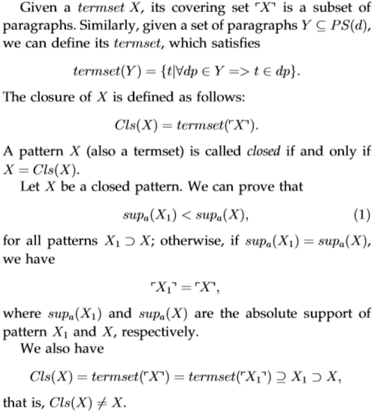

Paragraph | Terms
dp1 | t1,t2
dp2 | t3 t4 t6
dp3 | t3 t4 t5 t6
dp4 | t3 t4 t5 t6
dp5 | t1 t2 t6 t7
dp6 | t1 t2 t6 t7

Table-1

Frequent Pattern | Covering Set
{t3,t4,t6} | {dp2,dp3,dp4}
{t3,t4} | {dp2,dp3,dp4}
{t3,t6} | {dp2,dp3,dp4}
{t4,t6} | {dp2,dp3,dp4}
{t3} | {dp2,dp3,dp4}
{t4} | {dp2,dp3,dp4}
{t1,t2} | {dp1,dp5,dp6}
{t1} | {dp1,dp5,dp6}
{t2} | {dp1,dp5,dp6}
{t6} | {dp2,dp3,dp4,dp5,dp6}

Table-2

Pattern Taxonomy:

{_{t3, t4, t6}}

[2
{_{t3, t4}}
{_{t3, t6}}
{_{t4, t6}}
{_{t1, t2}}
{_{t1}}
{_{t2}}
{_{t3}}
{_{t4}}
{_{t6}}
[2, 3, 4]
[2, 3, 4]
[2, 3, 4]
[2, 3, 4]
[2, 3, 4]
[2, 3, 4]
[2, 3, 4, 5, 6]
[1, 5, 6]
[1, 5, 6]
[1, 5, 6]
Patterns can be structured into a taxonomy by using the is-a (or subset) relation. For the example of Table 1, where we have illustrated a set of paragraphs of a document, and the discovered 10 frequent patterns in Table 2 if
assuming min sup ¼ 50%. There are, however, only three closed patterns in this example. They are <t3; t4; t6>,
<t1; t2>, and <t6>.Above Fig illustrates an example of the pattern taxonomy for the frequent patterns in Table 2, where the nodes represent frequent patterns and their covering sets; nonclosed patterns can be pruned; the edges are “is-a” relation. After pruning, some direct “is-a” retaliations may be changed, for example, pattern ft6g would become a direct subpattern of ft3; t4; t6g after pruning nonclosed patterns.

- System Analysis
3.1 Study of the System:
To provide flexibility to the users, the interfaces have been developed that are accessible through a browser. The GUI’S at the top level have been categorized as
- Administrative user interface
- The operational or generic user interface

The ‘administrative user interface’ concentrates on the consistent information that is practically, part of the organizational activities and which needs proper authentication for the data collection. These interfaces help the administrators with all the transactional states like Data insertion, Data deletion and Date updating along with the extensive data search capabilities.
The ‘operational or generic user interface’ helps the end users of the system in transactions through the existing data and required services. The operational user interface also helps the ordinary users in managing their own information in a customized manner as per the included flexibilities
SDLC is nothing but Software Development Life Cycle. It is a standard which is used by software industry to develop good software.
Stages in SDLC:
- Requirement Gathering
- Analysis
- Designing
- Coding
- Testing
- Maintenance

3.2 Requirements Analysis
SDLC (Spiral Model):
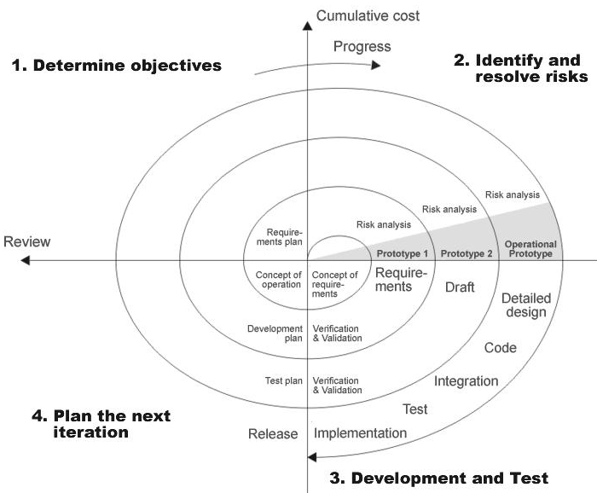

Requirements Gathering stage:
The requirements gathering process takes as its input the goals identified in the high-level requirements section of the project plan. Each goal will be refined into a set of one or more requirements. These requirements define the major functions of the intended application, define operational data areas and reference data areas, and define the initial data entities. Major functions include critical processes to be managed, as well as mission critical inputs, outputs and reports. A user class hierarchy is developed and associated with these major functions, data areas, and data entities. Each of these definitions is termed a Requirement. Requirements are identified by unique requirement identifiers and, at minimum, contain a requirement title and textual description.
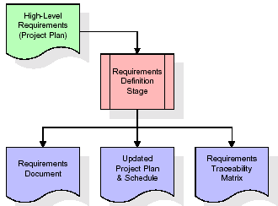

These requirements are fully described in the primary deliverables for this stage: the Requirements Document and the Requirements Traceability Matrix (RTM). The requirements document contains complete descriptions of each requirement, including diagrams and references to external documents as necessary. Note that detailed listings of database tables and fields are not included in the requirements document.
The title of each requirement is also placed into the first version of the RTM, along with the title of each goal from the project plan. The purpose of the RTM is to show that the product components developed during each stage of the software development lifecycle are formally connected to the components developed in prior stages.
In the requirements stage, the RTM consists of a list of high-level requirements, or goals, by title, with a listing of associated requirements for each goal, listed by requirement title. In this hierarchical listing, the RTM shows that each requirement developed during this stage is formally linked to a specific product goal. In this format, each requirement can be traced to a specific product goal, hence the term requirements traceability.
The outputs of the requirements definition stage include the requirements document, the RTM, and an updated project plan.
- Feasibility study is all about identification of problems in a project.
- No. of staff required to handle a project is represented as Team Formation, in this case only modules are individual tasks will be assigned to employees who are working for that project.
- Project Specifications are all about representing of various possible inputs submitting to the server and corresponding outputs along with reports maintained by administrator

Analysis Stage:
The planning stage establishes a bird's eye view of the intended software product, and uses this to establish the basic project structure, evaluate feasibility and risks associated with the project, and describe appropriate management and technical approaches.
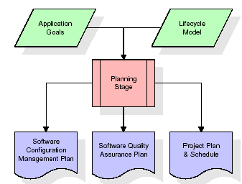

The most critical section of the project plan is a listing of high-level product requirements, also referred to as goals. All of the software product requirements to be developed during the requirements definition stage flow from one or more of these goals. The minimum information for each goal consists of a title and textual description, although additional information and references to external documents may be included. The outputs of the project planning stage are the configuration management plan, the quality assurance plan, and the project plan and schedule, with a detailed listing of scheduled activities for the upcoming Requirements stage, and high level estimates of effort for the out stages.
Designing Stage:
The design stage takes as its initial input the requirements identified in the approved requirements document. For each requirement, a set of one or more design elements will be produced as a result of interviews, workshops, and/or prototype efforts. Design elements describe the desired software features in detail, and generally include functional hierarchy diagrams, screen layout diagrams, tables of business rules, business process diagrams, pseudo code, and a complete entity-relationship diagram with a full data dictionary. These design elements are intended to describe the software in sufficient detail that skilled programmers may develop the software with minimal additional input.
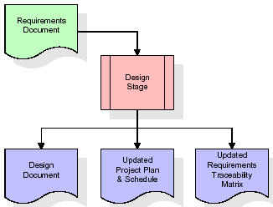

When the design document is finalized and accepted, the RTM is updated to show that each design element is formally associated with a specific requirement. The outputs of the design stage are the design document, an updated RTM, and an updated project plan.

Development (Coding) Stage:
The development stage takes as its primary input the design elements described in the approved design document. For each design element, a set of one or more software artifacts will be produced. Software artifacts include but are not limited to menus, dialogs, data management forms, data reporting formats, and specialized procedures and functions. Appropriate test cases will be developed for each set of functionally related software artifacts, and an online help system will be developed to guide users in their interactions with the software.
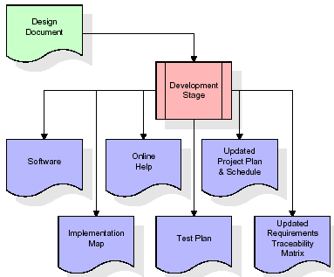

The RTM will be updated to show that each developed artifact is linked to a specific design element, and that each developed artifact has one or more corresponding test case items. At this point, the RTM is in its final configuration. The outputs of the development stage include a fully functional set of software that satisfies the requirements and design elements previously documented, an online help system that describes the operation of the software, an implementation map that identifies the primary code entry points for all major system functions, a test plan that describes the test cases to be used to validate the correctness and completeness of the software, an updated RTM, and an updated project plan.

Integration & Test Stage:
During the integration and test stage, the software artifacts, online help, and test data are migrated from the development environment to a separate test environment. At this point, all test cases are run to verify the correctness and completeness of the software. Successful execution of the test suite confirms a robust and complete migration capability. During this stage, reference data is finalized for production use and production users are identified and linked to their appropriate roles. The final reference data (or links to reference data source files) and production user list are compiled into the Production Initiation Plan.
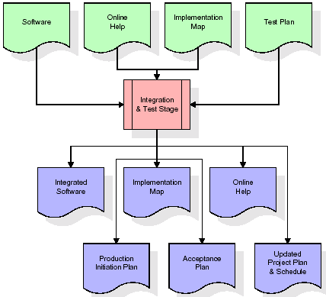

The outputs of the integration and test stage include an integrated set of software, an online help system, an implementation map, a production initiation plan that describes reference data and production users, an acceptance plan which contains the final suite of test cases, and an updated project plan.
Installation & Acceptance Test:
During the installation and acceptance stage, the software artifacts, online help, and initial production data are loaded onto the production server. At this point, all test cases are run to verify the correctness and completeness of the software. Successful execution of the test suite is a prerequisite to acceptance of the software by the customer.
After customer personnel have verified that the initial production data load is correct and the test suite has been executed with satisfactory results, the customer formally accepts the delivery of the software.
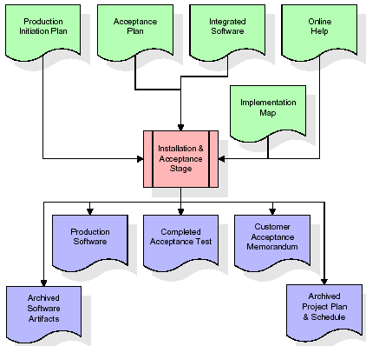
The primary outputs of the installation and acceptance stage include a production application, a completed acceptance test suite, and a memorandum of customer acceptance of the software. Finally, the PDR enters the last of the actual labor data into the project schedule and locks the project as a permanent project record. At this point the PDR "locks" the project by archiving all software items, the implementation map, the source code, and the documentation for future reference.

  - System Architecture:
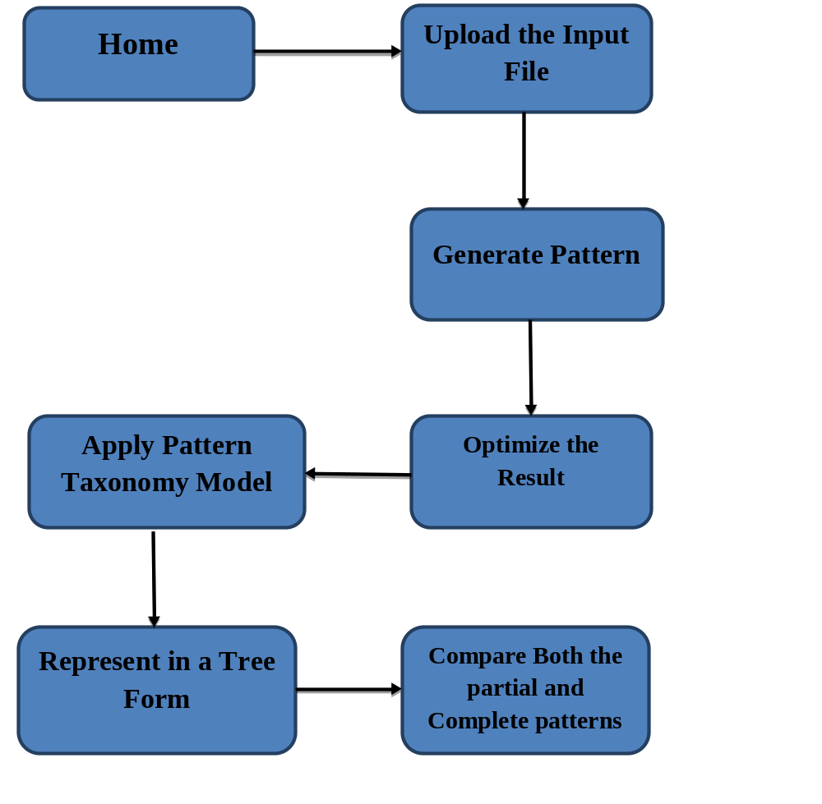
3.4 Data Flow Diagram:
- The DFD is also called as bubble chart. It is a simple graphical formalism that can be used to represent a system in terms of input data to the system, various processing carried out on this data, and the output data is generated by this system.
- The data flow diagram (DFD) is one of the most important modeling tools. It is used to model the system components.
- DFD shows how the information moves through the system and how it is modified by a series of transformations. It is a graphical technique that depicts information flow and the transformations that are applied as data moves from input to output.
4. DFD is also known as bubble chart. A DFD may be used to represent a system at any level of abstraction
.
Home
Input Data Files
Upload a File from the Database
Generate the Pattern
Apply Pattern Taxonomy Model

Optimize the result

3.5. Feasibility Study:
Preliminary investigation examines project feasibility; the likelihood the system will be useful to the organization. The main objective of the feasibility study is to test the Technical, Operational and Economical feasibility for adding new modules and debugging old running system. All systems are feasible if they are given unlimited resources and infinite time. There are aspects in the feasibility study portion of the preliminary investigation

- Technical Feasibility
- Operational Feasibility
- Economical Feasibility

3.5.1 Technical Feasibility:
The technical issue usually raised during the feasibility stage of the investigation includes the following:
- Does the necessary technology exist to do what is suggested?
- Do the proposed equipments have the technical capacity to hold the data required to use the new system?
- Will the proposed system provide adequate response to inquiries, regardless of the number or location of users?
- Can the system be upgraded if developed?
Are there technical guarantees of accuracy, reliability, ease of access and data security?
3.5.2 Operational Feasibility
User-friendly
Customer will use the forms for their various transactions i.e. for adding new routes, viewing the routes details. Also the Customer wants the reports to view the various transactions based on the constraints. These forms and reports are generated as user-friendly to the Client.
Reliability
The package wills pick-up current transactions on line. Regarding the old transactions, User will enter them in to the system.
Security
The web server and database server should be protected from hacking, virus etc
Portability
The application will be developed using standard open source software (Except Oracle) like Java, tomcat web server, Internet Explorer Browser etc these software will work both on Windows and Linux o/s. Hence portability problems will not arise.
Availability
This software will be available always.
Maintainability
The system called the ewheelz uses the 2-tier architecture. The 1st tier is the GUI, which is said to be front-end and the 2nd tier is the database, which uses My-Sql, which is the back-end.
The front-end can be run on different systems (clients). The database will be running at the server. Users access these forms by using the user-ids and the passwords.
3.5.3 Economic Feasibility
The computerized system takes care of the present existing system’s data flow and procedures completely and should generate all the reports of the manual system besides a host of other management reports.
It should be built as a web based application with separate web server and database server. This is required as the activities are spread throughout the organization customer wants a centralized database. Further some of the linked transactions take place in different locations
Open source software like TOMCAT, JAVA, Mysql and Linux is used to minimize the cost for the Customer.

3.6. Functional Requirements Specification
Modules:
- Loading document
- Text Preprocessing
- Pattern taxonomy process
- Pattern deploying

1. Loading document:
This module is used to load the document and the user will retrieve that document for further operation. ( preprocessing ).
2. Text Preprocessing :
The retrieved document preprocessing is done in module. Stemming is the process for reducing inflected (or sometimes derived) words to their stem base or root form. It generally a written word forms.
3. Pattern taxonomy model:
We assume that all documents are split into paragraphs. So a given document d yields a set of paragraphs. Let D be a training set of documents, which consists of a set of positive documents and a set of negative documents.
4. Pattern deploying method:
In order to use the semantic information in the pattern taxonomy to improve the performance of closed patterns in text mining, we need to interpret discovered patterns by summarizing them as d-patterns (see the definition below) in order to accurately evaluate term weights (supports). The rational behind this motivation is that d-patterns include more semantic meaning than terms that are selected based on a term-based technique (e.g., tf*idf).
3.7 Performance Requirements
Performance is measured in terms of the output provided by the application. Requirement specification plays an important part in the analysis of a system. Only when the requirement specifications are properly given, it is possible to design a system, which will fit into required environment. It rests largely with the users of the existing system to give the requirement specifications because they are the people who finally use the system. This is because the requirements have to be known during the initial stages so that the system can be designed according to those requirements. It is very difficult to change the system once it has been designed and on the other hand designing a system, which does not cater to the requirements of the user, is of no use.
The requirement specification for any system can be broadly stated as given below:
The system should be able to interface with the existing system
- The system should be accurate
- The system should be better than the existing system
The existing system is completely dependent on the user to perform all the duties.

3.8 H/W System Configuration:-

Processor - Pentium –III
Speed - 1.1 Ghz
RAM - 256 MB(min)
Hard Disk - 20 GB
Key Board - Standard Windows Keyboard
Mouse - Two or Three Button Mouse
Monitor - SVGA

3.9 S/W System Configuration:-

Operating System : Windows/XP/7/8/8.1
Front End : Swings
Language : Java.
- Introduction To Java
About Java:
Initially the language was called as “oak” but it was renamed as “java” in 1995.The primary motivation of this language was the need for a platform-independent(i.e. architecture neutral)language that could be used to create software to be embedded in various consumer electronic devices.
- Java is a programmer’s language
- Java is cohesive and consistent
- Except for those constraint imposed by the Internet environment. Java gives the programmer, full control

Finally Java is to Internet Programming where c was to System Programming.
Importance of Java to the Internet:
Java has had a profound effect on the Internet. This is because; java expands the Universe of objects that can move about freely in Cyberspace. In a network, two categories of objects are transmitted between the server and the personal computer. They are passive information and Dynamic active programs. in the areas of Security and probability. But Java addresses these concerns and by doing so, has opened the door to an exciting new form of program called the Applet.
Applications and applets:
An application is a program that runs on our Computer under the operating system of that computer. It is more or less like one creating using C or C++ .Java’s ability to create Applets makes it important. An Applet I san application, designed to be transmitted over the Internet and executed by a Java-compatible web browser. An applet I actually a tiny Java program, dynamically downloaded across the network, just like an image. But the difference is, it is an intelligent program, not just a media file. It can be react to the user input and dynamically change.

Java Architecture:
Java architecture provides a portable, robust, high performing environment for development. Java provides portability by compiling the byte codes for the Java Virtual Machine, which is then interpreted on each platform by the run-time environment. Java is a dynamic system, able to load code when needed from a machine in the same room or across the planet.

Compilation of code:

When you compile the code, the Java compiler creates machine code (called byte code)for a hypothetical machine called Java Virtual Machine(JVM). The JVM is supposed t executed the byte code. The JVM is created for the overcoming the issue of probability. The code is written and compiled for one machine and interpreted on all machines .This machine is called Java Virtual Machine.
Compiling and interpreting java source code.

Source code
Pc compiler
Macintosh compiler
SPARC Compiler
Java Byte code

Platform independent
Java interpreter
Java interpretermacintosh

)))

Java interpreter(SPARC)
During run-time the Java interpreter tricks the byte code file into thinking that it is running on a Java Virtual Machine. In reality this could be an Intel Pentium windows 95 or sun SPARCstation running Solaris or Apple Macintosh running system and all could receive code from any computer through internet and run the Applets.
Simple:
Java was designed to be easy for the Professional programmer to learn and to use effectively. If you are an experienced C++ Programmer. Learning Java will oriented features of C++. Most of the confusing concepts from C++ are either left out of Java or implemented in a cleaner, more approachable manner. In Java there are a small number of clearly defined ways to accomplish a given task.

Object oriented:
Java was not designed to be source-code compatible with any other language. This allowed the Java team the freedom to design with a blank state. One outcome of this was a clean usable, pragmatic approach to objects. The object model in Java is simple and easy to extend, while simple types, such as integers, are kept as high-performance non-objects.

Robust:
The multi-platform environment of the web places extraordinary demands on a program, because the program must execute reliably in a variety of systems. The ability to create robust programs. Was given a high priority in the design of Java. Java is strictly typed language; it checks your code at compile time and runtime.
Java virtually eliminates the problems of memory management and deal location, which is completely automatic. In a well-written Java program, all run-time errors can and should be managed by your program.
AWT and Swings:
Graphical User Interface:
The user interface is that part of a program that interacts with the user of the program. GUI is a type of user interface that allows users to interact with electronic devices with images rather than text commands. A class library is provided by the Java programming language which is known as Abstract Window Toolkit (AWT) for writing graphical programs. The Abstract Window Toolkit (AWT) contains several graphical widgets which can be added and positioned to the display area with a layout manager.
As the Java programming language, the AWT is not platform-independent. AWT uses system peers object for constructing graphical widgets. A common set of tools is provided by the AWT for graphical user interface design. The implementation of the user interface elements provided by the AWT is done using every platform's native GUI toolkit. One of the AWT's significance is that the look and feel of each platform can be preserved.
Components:
A graphical user interface is built of graphical elements called components. A component is an object having a graphical representation that can be displayed on the screen and that can interact with the user. Components allow the user to interact with the program and provide the input to the program. In the AWT, all user interface components are instances of class Component or one of its subtypes. Typical components include such items as buttons, scrollbars, and text fields.
Types of Components:
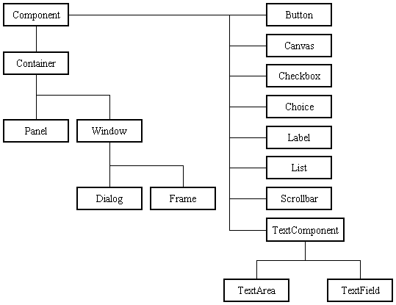
Before proceeding ahead, first we need to know what containers are. After learning containers we learn all components in detail.
Containers:
Components do not stand alone, but rather are found within containers. In order to make components visible, we need to add all components to the container. Containers contain and control the layout of components. In the AWT, all containers are instances of class Container or one of its subtypes. Components must fit completely within the container that contains them. For adding components to the container we will use add() method.
Types of containers:
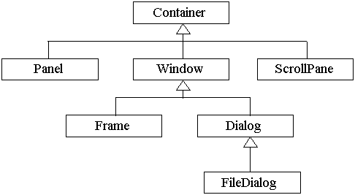
Basic GUI Logic:
The GUI application or applet is created in three steps. These are:
- Add components to Container objects to make your GUI.
- Then you need to setup event handlers for the user interaction with GUI.
- Explicitly display the GUI for application.
- System Design
5.1 Introduction:
Systems design is the process or art of defining the architecture, components, modules, interfaces, and data for a system to satisfy specified requirements. One could see it as the application of systems theory to product development. There is some overlap and synergy with the disciplines of systems analysis, systems architecture and systems engineering.
5.2 Input & Output Representation
Input design is a part of overall system design. The main objective during the input design is as given below:
- To produce a cost-effective method of input.
- To achieve the highest possible level of accuracy.
- To ensure that the input is acceptable and understood by the user.

Input Media:
At this stage choice has to be made about the input media. To conclude about the input media consideration has to be given to;
- Type of input
- Flexibility of format
- Speed
- Accuracy
- Verification methods
- Rejection rates
- Ease of correction
- Storage and handling requirements
- Security
- Easy to use
- Portability
Keeping in view the above description of the input types and input media, it can be said that most of the inputs are of the form of internal and interactive. As
Input data is to be the directly keyed in by the user, the keyboard can be considered to be the most suitable input device.
Output Design:
In general are:
- External Outputs whose destination is outside the organization.
- Internal Outputs whose destination is with in organization and they are the User’s main interface with the computer. Outputs from computer systems are required primarily to communicate the results of processing to users. They are also used to provide a permanent copy of the results for later consultation. The various types of outputs
- Operational outputs whose use is purely with in the computer department.
- Interface outputs, which involve the user in communicating directly with the system.

Output Definition

The outputs should be defined in terms of the following points:
    - Type of the output
    - Content of the output
    - Format of the output
    - Location of the output
    - Frequency of the output
    - Volume of the output
    - Sequence of the output

It is not always desirable to print or display data as it is held on a computer. It should be decided as which form of the output is the most suitable.
For Example
- Will decimal points need to be inserted
- Should leading zeros be suppressed.

Output Media:
In the next stage it is to be decided that which medium is the most appropriate for the output. The main considerations when deciding about the output media are:
- The suitability for the device to the particular application.
- The need for a hard copy.
- The response time required.
- The location of the users
- The software and hardware available.

The outputs were needed to be generated as a hard copy and as well as queries to be viewed on the screen. Keeping in view these outputs, the format for the output is taken from the outputs, which are currently being obtained after manual processing. The standard printer is to be used as output media for hard copies.
5.3 UML Diagrams:
Unified Modeling Language:
The Unified Modeling Language allows the software engineer to express an analysis model using the modeling notation that is governed by a set of syntactic semantic and pragmatic rules.
A UML system is represented using five different views that describe the system from distinctly different perspective. Each view is defined by a set of diagram, which is as follows.
  - User Model View
    - This view represents the system from the users perspective.
    - The analysis representation describes a usage scenario from the end-users perspective.

  - Structural model view
    - In this model the data and functionality are arrived from inside the system.
    - This model view models the static structures.

- Behavioral Model View
It represents the dynamic of behavioral as parts of the system, depicting the interactions of collection between various structural elements described in the user model and structural model view.
- Implementation Model View
In this the structural and behavioral as parts of the system are represented as they are to be built.
- Environmental Model View
In this the structural and behavioral aspects of the environment in which the system is to be implemented are represented.
UML is specifically constructed through two different domains they are:
- UML Analysis modeling, this focuses on the user model and structural model views of the system.
- UML design modeling, which focuses on the behavioral modeling, implementation modeling and environmental model views.

Use case Diagrams represent the functionality of the system from a user’s point of view. Use cases are used during requirements elicitation and analysis to represent the functionality of the system. Use cases focus on the behavior of the system from external point of view.
Actors are external entities that interact with the system. Examples of actors include users like administrator, bank customer …etc., or another system like central database.

UML DIAGRAMS
Class Diagram: The purpose of the class diagram is to model the static view of an application. The class diagrams are the only diagrams which can be directly mapped with object oriented languages and thus widely used at the time of construction.
Use Case Diagram: The purpose of use case diagram is to capture the dynamic aspect of a system. But this definition is too generic to describe the purpose.Use case diagrams are used to gather the requirements of a system including internal and external influences. These requirements are mostly design requirements. So when a system is analyzed to gather its functionalities use cases are prepared and actors are identified.
Sequence Diagram: The purposes of interaction diagrams are to visualize the interactive behaviour of the system. Now visualizing interaction is a difficult task. So the solution is to use different types of models to capture the different aspects of the interaction. That is why sequence and collaboration diagrams are used to capture dynamic nature but from a different angle.
Collaboration Diagram: The second interaction diagram is collaboration diagram. It shows the object organization as shown below. Here in collaboration diagram the method call sequence is indicated by some numbering technique as shown below. The number indicates how the methods are called one after another. We have taken the same order management system to describe the collaboration diagram.
DEPLOYMENT DIAGRAM: Deployment diagrams are used to visualize the topology of the physical components of a system where the software components are deployed.So deployment diagrams are used to describe the static deployment view of a system. Deployment diagrams consist of nodes and their relationships

Class diagram for Text Analysis:

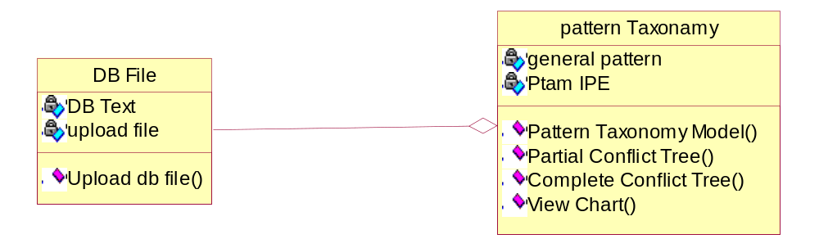

Use case diagrams for Database file:
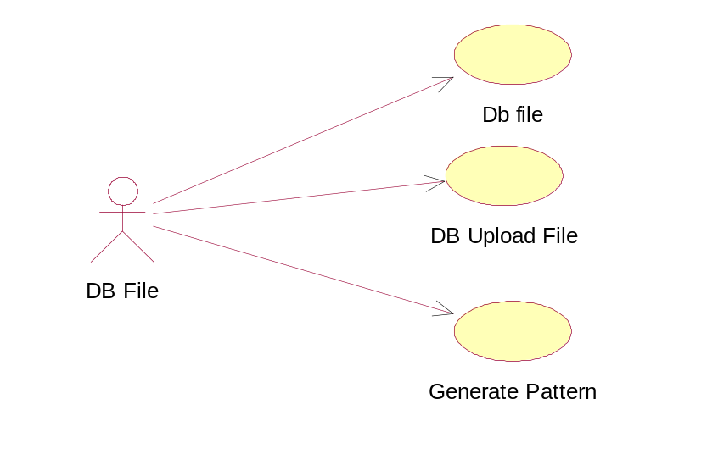

Use case diagram for Generate Pattern:
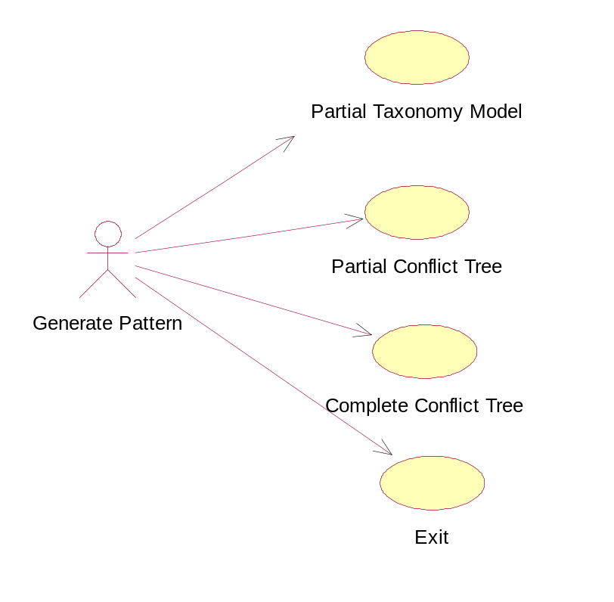

Sequence diagram for DB File:
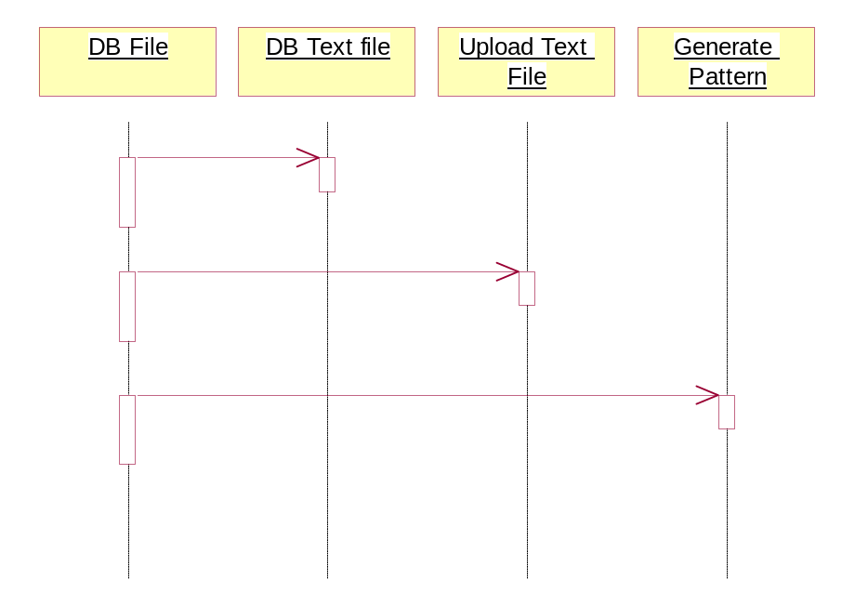

Collaboration diagram for DataBase File
:
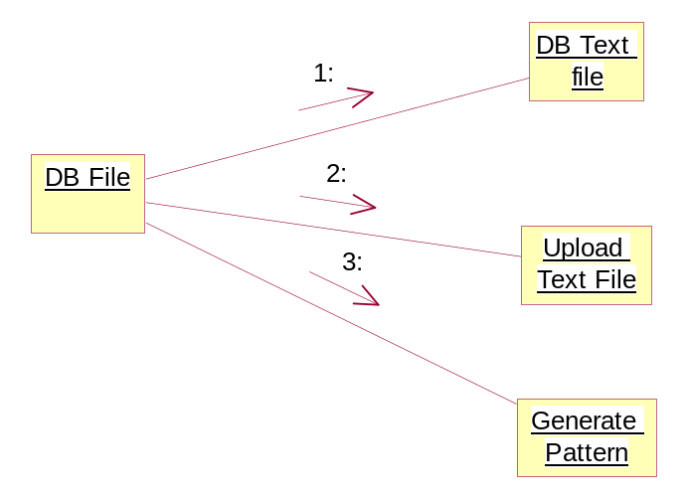

Sequence diagram for Generate Pattern:
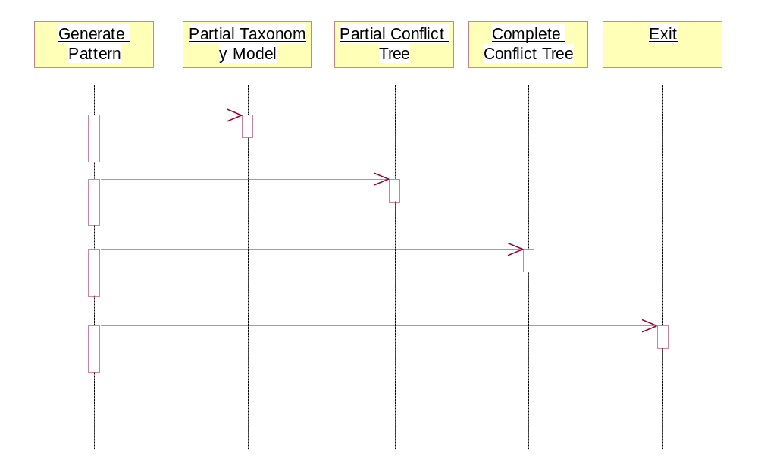

Collaboration diagram for Generate Pattern:
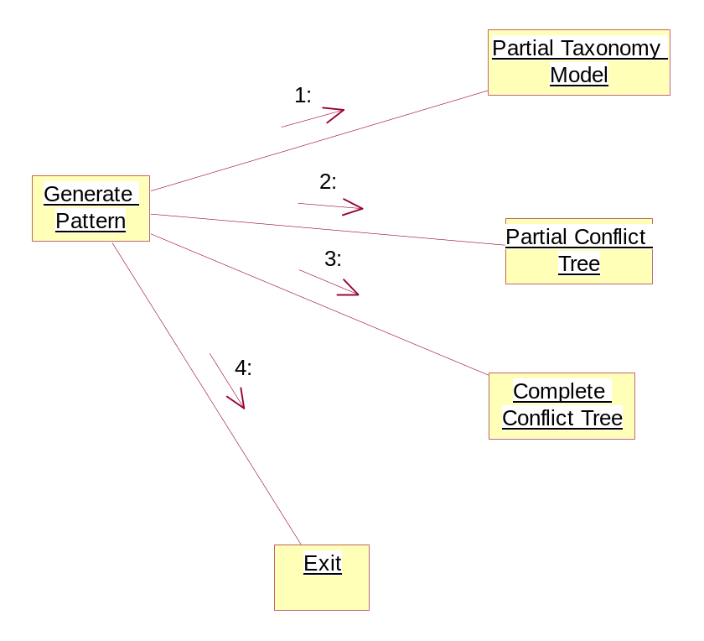
Component diagram for DB File:
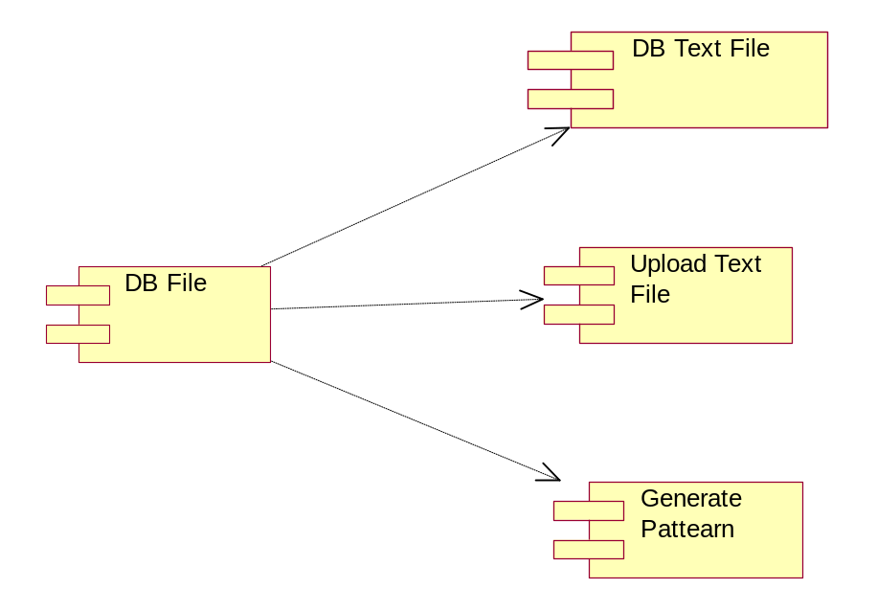

Component diagram for Generate Pattern:
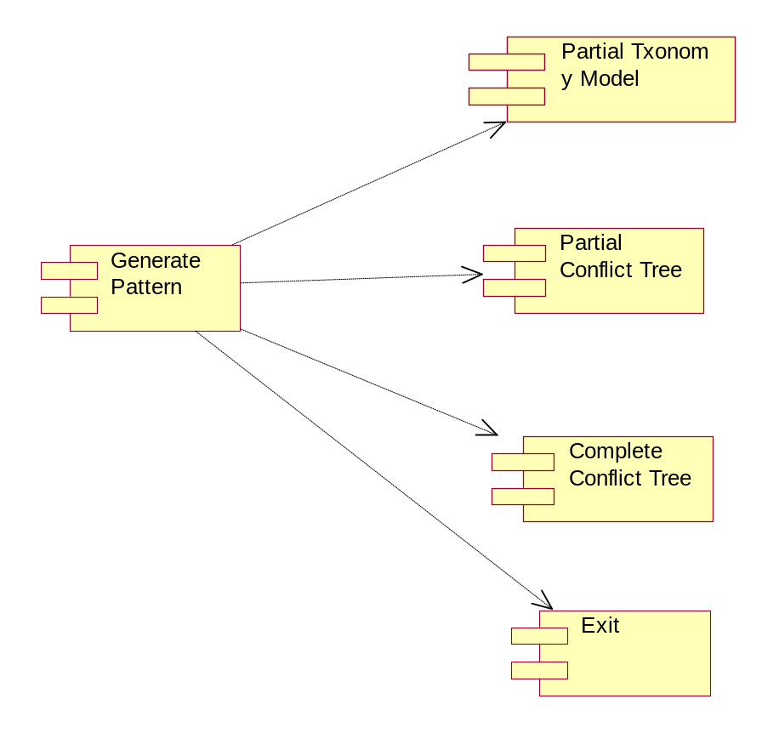

Deployment diagram for DB File:

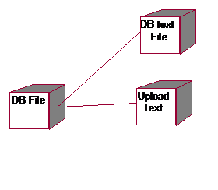

- Output Screens

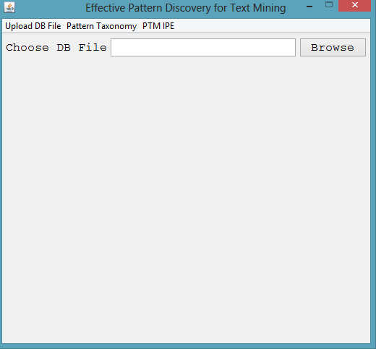
Fig 6.1 Describes about home screen

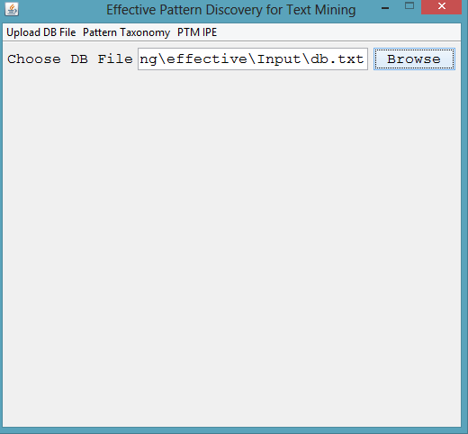
Fig 6.2 Describes about browsing an input text file

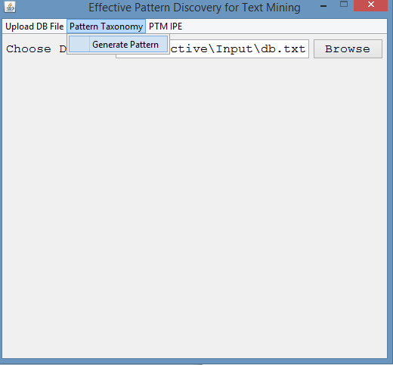
Fig 6.3 Describes about the process of generating pattern

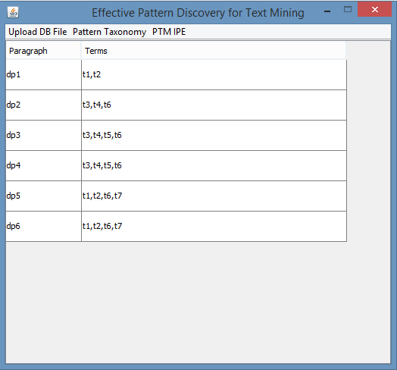
Fig 6.4 Describes about the generated pattern

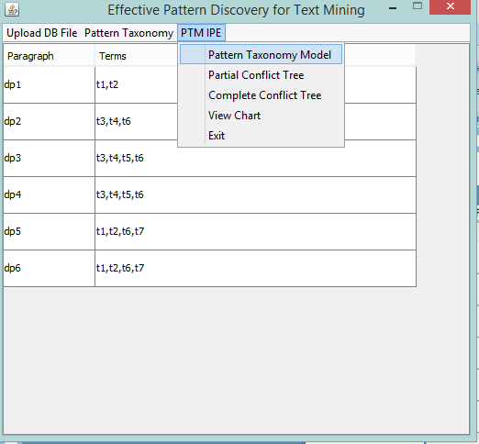
Fig 6.5 Describes about generating pattern taxonomy model

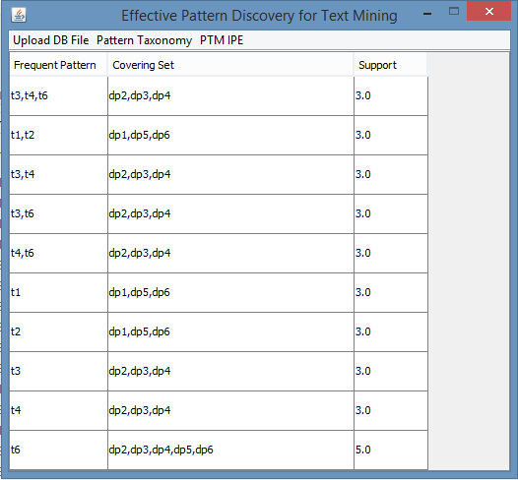
Fig 6.6 Describes the generated pattern

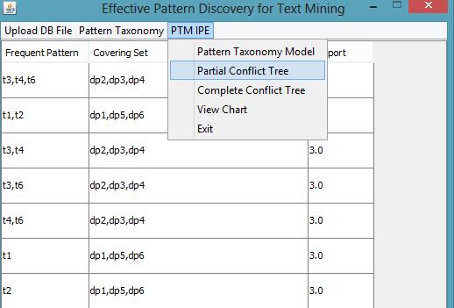
Fig 6.7 Describes about selecting Partial Conflict Tree

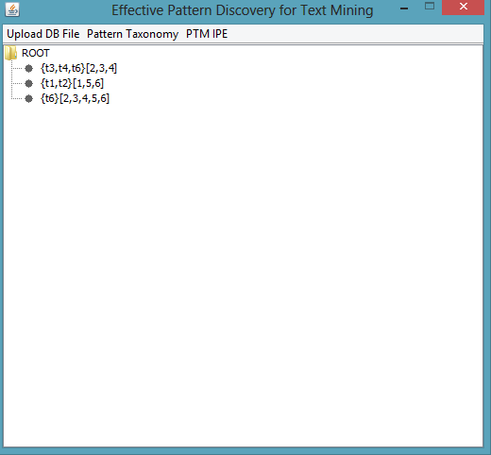
Fig 6.8 Describes about display of Partial conflict Tree

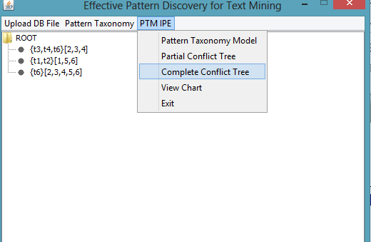
Fig 6.9 Describes about selecting Complete Conflict tree

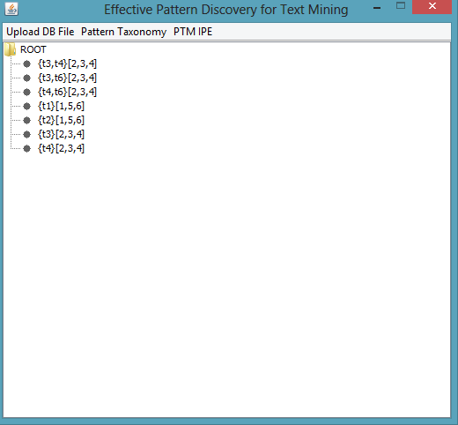
Fig 6.10 Describes about displaying of Complete conflict tree

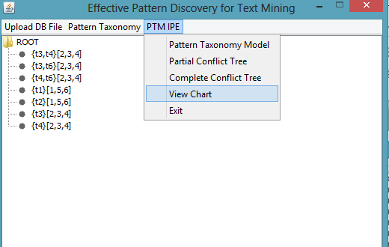
Fig 6.11 Describes about selecting View chart

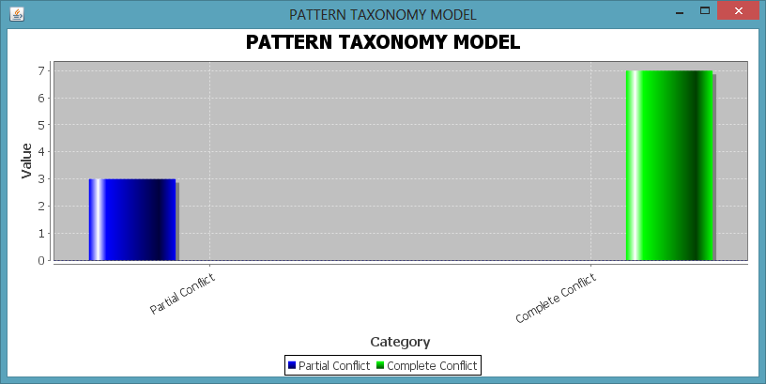
Fig 6.12 Describes about displaying of View Chart

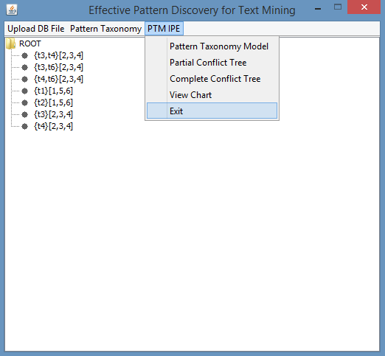
Fig 6.13 Describes about exit
- System Testing
7.1 Introduction to Testing
Introduction to Testing:
Testing is a process, which reveals errors in the program. It is the major quality measure employed during software development. During software development. During testing, the program is executed with a set of test cases and the output of the program for the test cases is evaluated to determine if the program is performing as it is expected to perform.
7.2 Testing Strategies:
In order to make sure that the system does not have errors, the different levels of testing strategies that are applied at differing phases of software development are:
Unit Testing:
Unit Testing is done on individual modules as they are completed and become executable. It is confined only to the designer's requirements.
Each module can be tested using the following two Strategies:
Black Box Testing:
In this strategy some test cases are generated as input conditions that fully execute all functional requirements for the program. This testing has been uses to find errors in the following categories:
- Incorrect or missing functions
- Interface errors
- Errors in data structure or external database access
- Performance errors
- Initialization and termination errors.
In this testing only the output is checked for correctness.
The logical flow of the data is not checked.

White Box testing:
In this the test cases are generated on the logic of each module by drawing flow graphs of that module and logical decisions are tested on all the cases. It has been uses to generate the test cases in the following cases:
- Guarantee that all independent paths have been Executed.
- Execute all logical decisions on their true and false Sides.
- Execute all loops at their boundaries and within their operational bounds
- Execute internal data structures to ensure their validity.
Integrating Testing:
Integration testing ensures that software and subsystems work together a whole. It tests the interface of all the modules to make sure that the modules behave properly when integrated together.
System Testing:
Involves in-house testing of the entire system before delivery to the user. Its aim is to satisfy the user the system meets all requirements of the client's specifications.
Acceptance Testing:
It is a pre-delivery testing in which entire system is tested at client's site on real world data to find errors.

Test Approach:
Testing can be done in two ways:
- Bottom up approach
- Top down approach

Bottom up Approach:
Testing can be performed starting from smallest and lowest level modules and proceeding one at a time. For each module in bottom up testing a short program executes the module and provides the needed data so that the module is asked to perform the way it will when embedded within the larger system. When bottom level modules are tested attention turns to those on the next level that use the lower level ones they are tested individually and then linked with the previously examined lower level modules.
Top down approach:
This type of testing starts from upper level modules. Since the detailed activities usually performed in the lower level routines are not provided stubs are written. A stub is a module shell called by upper level module and that when reached properly will return a message to the calling module indicating that proper interaction occurred. No attempt is made to verify the correctness of the lower level module.
Validation:
The system has been tested and implemented successfully and thus ensured that all the requirements as listed in the software requirements specification are completely fulfilled. In case of erroneous input corresponding error messages are displayed
7.3 Test Cases:
A Test case is a set of conditions and variables under which a tester will determine whether a system under test identifies requirements on works correctly the process of developing test cases can also help requirement on design of an application
Manual Testing:
Testing when carried out without any help of any tool is called manual testing. When user is required to carry out every activity related to testing manually say it as a manual testing process
Steps for Manual Testing:
- Understand the functionality of an application
- Prepare test plan
- Write the test case and execute it
- Verify actual and expected results
- Prepare bug report
- After receiving the modified build from developers e ill go for testing and regression testing, These process are repeated until bug status is closed
Test case description
A test case is step by step instructions to test a specific requirements on step by step during direction to check specific functionality
Test scenario: a document specifying a sequence of actions for execution of test
Test case: one or more i/p values execution preconditions steps for execution expected values & execution values. Conditions developed for particular object or test condition
Test Data: Data that exist before a test is executed & that affects or is affected by component or system under test
7.3.1. Test Cases Document:
TEST CASES DOCUMENT
Project Name:  <EFFECTIVE PATTERN DISCOVERY> | Module Name:  < TEXT MINING> | Prepared By:  < TEAM> | Executed on:  < 30/04/2015> | Reviewed on:  <01/05/2015>
Test case Id | Test case description | Test data | Expected result | Status
1 | browsing the  document | File with the appropriate extension | valid document | Pass
2 | browsing the  document | File with the inappropriate extension | Valid document | Fail
3 | uploading the  document | document with terms | valid document | Pass
4 | uploading the  document | document with terms | Valid document | Fail
5 | pattern generation | assign terms to paragraphs | terms to para | Pass
6 | splitting the terms | terms seperated by comma | Assigned to Arraylist properly | Pass
Project Name:  <EFFECTIVE PATTERN DISCOVERY> | Module Name:  < TEXT MINING> | Prepared By:  < TEAM> | Executed on:  < 30/04/2015> | Reviewed on:  <01/05/2015>
Test case Id | Test case description | Test data | Expected result | Status
7 | splitting the terms | Terms not seperated by comma | Assigned to Arraylist properly | Fail
8 | generate pattern | applying algorithm | apply PTM | Pass
9 | tree generation | complete & partial trees | display trees | pass

8.Conclusion
Many data mining techniques have been proposed in the last decade. These techniques include association rule mining, frequent itemset mining, sequential pattern mining, maximum pattern mining, and closed pattern mining. However, using these discovered knowledge (or patterns) in the field of text mining is difficult and ineffective. The reason is that some useful long patterns with high specificity lack in support (i.e., the low-frequency problem). We convey that not all frequent short patterns are useful. Hence, misinterpretations of patterns derived from data mining techniques lead to the ineffective performance. In this research work, an effective pattern discovery technique has been proposed to overcome the low-frequency and misinterpretation problems for text mining. The proposed technique uses two processes, pattern deploying and pattern evolving, to refine the discovered patterns in text documents. The experimental results show that the proposed model outperforms not only other pure data mining-based methods and the concept based model, but also term-based state-of-the-art models.
9.Bibliography
References for the Project development were taken from the following Books, Papers and Web Sites.

BOOKS:
- Jiawei Han, ‎Micheline Kamber, ‎Jian Pei, Data Mining: Concepts and Techniques, Third Edition, Mourgan Couffman
- Roger Pressman , Software Engineering, Palgrave Macmillan
- Herbert Schildt , JAVA 2 Standard Edition, Tata-McGraw-Hill
PAPERS:
[1]Ning Zhong, Yuefeng Li, and Sheng-Tang Wu Effective Pattern Discovery for Text Mining
[2] R. Agrawal and R. Srikant, “Fast Algorithms for Mining Association Rules in Large Databases,” Proc. 20th Int’l Conf. Very Large Data Bases (VLDB ’94), pp. 478-499, 1994.
[3] J. Han and K.C.-C. Chang, “Data Mining for Web Intelligence,”Computer, vol. 35, no. 11, pp. 64-70, Nov. 2002.
[4] Y. Li and N. Zhong, “Interpretations of Association Rules by Granular Computing,” Proc. IEEE Third Int’l Conf. Data Mining (ICDM ’03), pp. 593-596, 2003.
[5] J.S. Park, M.S. Chen, and P.S. Yu, “An Effective Hash-Based Algorithm for Mining Association Rules,” Proc. ACM SIGMOD Int’l Conf. Management of Data (SIGMOD ’95), pp. 175-186, 1995.

WEBSITES:
- www.javatpoint.com/ArrayList-in-collection-framework
- www.tutorialspoint.com/java/java_arraylist_class.htm
- mathbits.com/MathBits/Java/arrays/BuiltInSort.htm
- stackoverflow.com

